- Professional communication
Tracking every communication between the FAA and the certificate holder is essential for quickly identifying and resolving issues. Use this Communications Log, in conjunction with the Issue Log, every time communication is send or receive from a government agency. Tracking communications from the beginning will enable quick deconstruction of an issue.
- Enter every communication, regardless of format, into the communications log; this includes telephone calls, emails, letters, notes and in-person communications.
- Provide the following information in the space provided:
  - Number (should automatically be generated as you create a new row.
  - Date (ex: 8/21/2015)
  - Type of Communication (see table in footer for abbreviations)
  - Sender: Who sent the message by name and contact information to the point where you can find or know who the heck it is or was (From)
  - Recipient (To): All the people it was sent to or abbreviations
  - Subject/Description
    - Describe in one to two sentences what is discussed in the communication.
    - For emails, include the subject line of the email, including “RE” and “FWD” identifiers.
  - Insert a copy of the communication and any additional information (e.g., attachments to emails)
    - Each communication should be saved individually and a copy inserted into the table. This is particularly important for emails where individuals may respond to an earlier email or merge email chains. Save each communication individually and ensure saved email contains the previous correspondence. This will enable agency representatives, legal counsel, and internal personnel to quickly review the communication.
    - See next page for instructions on how to insert a file into a table.
- Indicated the date on which the log was last updated in the header of the table.
- Example table for illustration only.
No. | Date | Type | From | To | Subject/Description | Copy of Comm/Add’l Info
 | (b) | (c) | (d) | € | (f) | (g)
- How to insert a file into a MS Word table:

- Save the communication as a PDF. For emails, we suggest saving them PDF format because not every organization uses Microsoft Outlook. Organizations using other email platforms will not be able to access emails saved as an Outlook file.
  - Outlook:
    - Click on the “File” tab
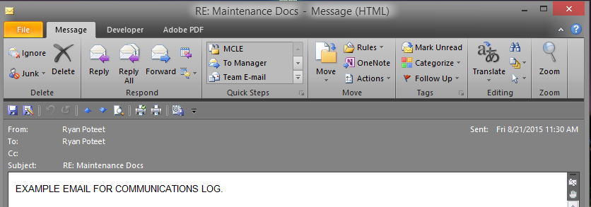

    - Select “save as Adobe PDF”
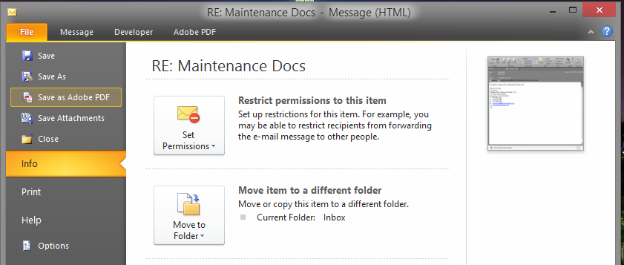

    - Save the file according to internal file naming protocols; however, we suggest Communication Type – Subject –Sender – Recipient – Date
- Ex: Email-RE_ Maintenance Docs – J.Doe to K.Doe -20150821
- Ex: Email_Attachment – FAA Form – RE_ Maintenance Docs – J.Doe to K.Doe – 20150821
- Ex: Letter – Notice of Proposed Civil Penalty – J.Doe to K.Doe – 20150821
  - Other email platforms – If your platform does not have a “Save to PDF option,” you can go to the “file” tab, select the “print” option, then choose “select printer” and select the “Print to PDF” option. This will allow you to save the file in PDF format.

- Drag the saved communication from the file folder to the communications log; this is the same process used to move files to your computer’s recycling bin/trash can. A copy of the communication will be inserted into the log while maintaining the original in the file folder. Repeat for email attachments.

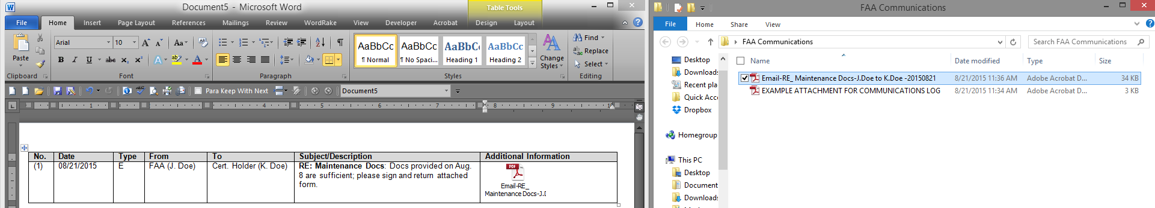

No. | Date | Type | From | To | Subject/Description | Copy of Comm/Add’l Info

